**HISTORIC SAVANNA-FOREST ECOTONES WERE SHARP, FOLLOWED ENVIRONMENTAL GRADIENTS**

ABSTRACT.— Historically, closed eastern forests transitioned into open savannas and prairies in the US Midwest, but this transition is poorly understood. To investigate the eastern boundary of the prairie-forest ecotone, we conducted a case study of historic and modern vegetation patterns of the Yellow River watershed in northwest Indiana. Historic vegetation came from survey notes from the 1800s Public Land Surveys, whereas modern vegetation came from the Forest Inventory Analysis and USGS National Land Cover Database.  Using ArcGIS, we mapped survey vegetation data to reconstruct the region’s past and current forest composition and structure. We also mapped climate, topography and soil composition across the watershed to investigate the relationship between historic vegetation and environmental gradients. We found a sharp transition in the pre-settlement forest structure and composition, with dense deciduous forests in the eastern portion of our study area and open oak savanna in the west. The savanna ecosystem dominated where soils were sandier and well-drained, as well as where elevation was modestly lower. Modest environmental changes accompanied major vegetation changes in the past, which might implicate amplifying roles of fire and hydrology. By contrast, the modern forest shows no difference in tree density and comp across the watershed, which is consistent with major land use and hydrology changes in the watershed since settlement. However, we found that the historically forested eastern portion is now more agriculturally productive, whereas the historic western savanna currently supports more mesic forest, suggesting that the environmental gradient continues to subtly shape the landscape. Though land use change has largely removed the closed mixed hardwood and oak savannas from this area, a better understanding of the historic vegetation and the conditions that supported it can help inform land management and restoration, as well as reveal ecological processes that drive vegetation transitions.

INTRODUCTION

The Midwestern prairie-forest ecotone, where the Prairie Peninsula historically met the deciduous forest biome, has been well-studied but is still not well-understood (Transeau, 1935; Curtis and McIntosh, 1951; Manogaran, 1983; Rogers and Anderson 1979;Haney *et al*., 2008). The pattern of the transitions between prairies, savannas and forests, as well as the factors that shape them, are the matter of some debate. Transeau (1935) first mapped the range of the Prairie Peninsula and provided an overview of its vegetation, climate and soils patterns.  Moving westward across the region, climate drives a continuum of increasingly xeric tree species and lower stem density (Anderson, 1998; Danz *et a*l., 2011). But at a smaller scale, where climatic differences are negligible, these ecosystems can have discrete boundaries and patchy distributions (Transeau, 1935; Kilburn, 1959; Almendinger, 1992). Both large and small-scale studies along the boundary describe close relationships between soil type and vegetation (Kilburn 1959Lindsey et al. 1965). But others have found modest or negligible associations between ecosystem shifts and soils; these suggest that soil and topography work primarily as indirect vegetation determinants, driving hydrological extremes and fire disturbance regimes (Grimm, 1984; Whitney and Steiger,1985; Almendinger, 1992; Danz *et al*., 2011). Furthermore, emerging research shows that environmental characterizations poorly predict vegetation in some savanna/forest transitions, proposing that internal feedbacks can hold these ecosystems as alternative stable states in similar environments (van Langevelde *et al*., 2003; Staver *et al*., 2011; Ratajczak *et al*., 2014). These diverging descriptions of the Midwestern ecotone and its accompanying environment highlight the need for more studies at a small, detailed scale.

Many have documented the ecotone’s northern ranges in Minnesota and Wisconsin (Umbanhowar, 2004; Grimm, 1984; Almendinger, 1992; Hanberry *et al*. 2012), western regions in Illinois (Bowles and Jones, 2004; Fahey *et al*., 2012), and southern reaches in Illinois and Missouri (Weaver, 1960; Batek *et al*., 1999; Brugam *et al*., 2016). But the eastern reaches of this boundary (Transeau, 1935, Paciorek *et al*., 2016), at its wet climatic extreme, are comparatively understudied. This is an important knowledge gap, as vegetation-environment relationships along the boundary appear to be spatially variable. Environmental features like morainic uplands, for example, have been linked to both oak-hickory and beech-maple associations in nearby regions in Illinois and Indiana (Cowles, 1901; Fuller, 1925). Understanding these vegetation-environment relationships becomes especially critical as ecosystem ranges and composition shift throughout the region with environmental change (Fahey *et al*., 2012). In particular, transitional ecosystems like oak savannas have experienced mesophication in the last century, threatening the exceptional biodiversity they support (Leach and Givnish, 1999; Nowacki and Abrams, 2008; Philippe *et al*., 2011). Remnant oak savanna ecosystems are increasingly rare, and conservation agencies want to understand the environmental conditions that best support savannas, as well as identify optimal areas for restoration to connect scattered patches (Fahey *et al*., 2015). Though little remnant vegetation historical land survey datasets from the early 19th century capture a snapshot of this region’s landscape before EuroAmerican settlement. These data afford the opportunity to explore the eastern regions of this vegetation transition and guide preservation and restoration efforts.

This study examines the historic vegetation transition, the underlying environmental gradient, and modern land cover of this eastern region of the ecotone. We used 19th century Public Land Surveys (PLS) data for the Yellow River watershed in northwest Indiana (Figure 1). Transeau’s (1935) ecotone map breaks this region into an eastern forest and western prairie region without detailing the sharpness of the transition, and it does not address vegetation and environment patterns specific to the mesic eastern edge of the transition. We also compare this original vegetation pattern with climate, soil and topography gradients and with current forest and land use patterns. In this study we answer three questions:

1: Do the PLS data show a sharp or gradual transition from closed mesic forest to open oak savanna?

2: Do environmental covariates correspond to the vegetation shift, spatially and in magnitude?

3. Are these vegetation gradients still visible on the modern landscape?

Based on Transeau’s coarse map of the region and of the general pattern of discontinuous vegetation changes between grassland, savanna and forest (van Langevelde *et al*., 2003; Nowacki and Abrams, 2008), we hypothesized that the PLS surveys would show a discrete structural and compositional boundary between eastern deciduous forest and western oak savanna. Additionally, fine-textured, morainal soils and sandy outwash soils have been linked to beech-maple and oak-hickory associations, respectively, in nearby studies (Kenoyer, 1933; Lindsey *et al*., 1965). This watershed historically experienced spring flooding as part of the greater Kankakee Marsh system (Ivens *et al*., 1981), and its hydrology could either encourage fire by increasing herbaceous fuel buildup (Higgins *et al*., 2000), or discourage fire by extending wet seasons (van Langevelde *et al*., 2003). Though these hydrological drivers have shown diverse relationships with vegetation (*see* Whitney and Steiger, 1985; but also Anderson and Anderson, 1975; Rogers and Anderson, 1979), we predict strong links between oak savanna distribution and hydrological variables- lower elevation and well-drained soils- as determinants of fire and flooding. Finally, we investigate the modern landscape, which has been heavily deforested, drained for agriculture and partially urbanized. Due to the widespread mesophication of transitional forests, and of the drastic changes in hydrology and land use, we do not expect to see evidence of historic ecotones or of differential edaphic influences on the modern landscape.

METHODS

STUDY AREA

Our study area in northwest Indiana is a 3000 km2 rectangular region encompassing the Yellow River watershed, the largest tributary to the Kankakee River (Figure 1). The Yellow River runs just under 100 km long, with an original developed length estimated to be three times longer, and drains 1127 km2 across the region (Chicago Sanitary District, 1895; Jonas and Little, 2010). The river flows southwest and drains six northern Indiana counties- Elkhart, Kosciusko, Marshall, La Porte, Starke and St. Joseph. Currently, the study area includes both sparsely populated (county population ~20,000) and heavily populated (county population >250,000) counties (United States Census Bureau, 2015). Due to the watershed’s irregular shape, two other rivers run through portions of our rectangular study system. The Kankakee River runs through the northwest corner, and the headwaters of the Tippecanoe run through the southeast corner. At the time of the historic surveys, the State of Indiana procured and set aside a mile-wide, north-south strip of the watershed for the construction of the Michigan Road (hereby referred to as the Michigan Road Lands; Prather, 1943). This area was surveyed differently from other PLS surveys used in our analyses (see below) and is not included in the dataset. The upper part of the Yellow River watershed is characterized by clay soils, whereas the lower third is sandy glacial outwash (Jonas and Little, 2010), and most of the basin is overlain with sand (Thompson, 1886). The Kankakee Watershed, which includes the Yellow River, is mostly level plains and depressions, and many parts were either seasonally or partially inundated (Woods *et al*., 2006). Continental glaciation in northwest Indiana formed wetlands that are not found in the Illinois side of the watershed (Ivens *et al*., 1981).

The Yellow River’s hydraulics, and consequently the region’s hydrology, have been significantly altered by development and agriculture (Christopher B. Burke Engineering, 2012). The eastern portion of the Yellow River was dredged and straightened in the early 1900s. The new man-made channel, dug only 2.5 meters wide instead of the proposed 6 meters, caused the land to be “much distressed” and led to severe erosion and deposition of silt and sand (Downey *et al*., 1909). The Yellow River contributes the largest load of sand to the Illinois River, due to issues related to watershed load and bank erosion (Jonas and Little 2010). There have been recent efforts to restore the hydrological health of the region and bring back native fauna (Christopher B. Burke Engineering, 2012; The Nature Conservancy, 2017).

DATA SOURCES

To reconstruct the pre-Euro-American settlement vegetation of the watershed, we used Public Land Surveys (PLS) conducted by the Government Land Office between 1829 and 1837. PLS records were obtained from the Indiana State Archives. The PLS system divided the land into townships made up of thirty-six sections, each one square mile in area. Surveyors set posts at half-mile intervals, recording the species, diameter and distance from the post of one to four bearing trees. These notes provide a ‘snapshot’ of the landscape when the region was relatively undisturbed by European settlement. The surveyors also drew plat maps outlining water and non-tree land features (such as prairie). The Yellow River watershed encompasses 32 townships. Data from the corner and quarter section corners of the PLS surveys were entered into a database by undergraduates in the McLachlan lab at the University of Notre Dame. The plat maps were digitized by the USGS. This dataset has some limitations, such as the inability to capture seasonality, potential sampling differences across multiple surveyors, and the possibility of bias in tree selection; however, by excluding subjectively-recorded ‘line’ trees and studying a sufficiently large area, these data can be a powerful tool to reconstruct historic vegetation (Manies and Mladenoff, 2001; Liu *et al*., 2011).

Several datasets were compiled to establish both the region’s environmental gradient and modern landscape. We used 30-yr Normal Mean Temperature and 30-yr Normal Precipitation rasters (calculated for the years 1981-2010, both at a resolution of 800 meters; from PRISM Climate Group) to evaluate climate across the region. We used a digital elevation map (DEM) with a 10m resolution from the USGS National Elevation Dataset. We also procured spatial soils data for the six Indiana counties in our study area from the Soils Survey Geographic Database (SSURGO; see appendix for full list and description). This dataset included indices for current land use, such as National Commodity Crop Productivity Index (NCCPI), soil erodibility, and categorical drainage class assessments. We used the National Land Cover Database (NLCD) 2006 Land Cover layer, a 30-meter grid modeling land cover in Indiana with 15 land use categories (Fry *et al*., 2011). This layer showed the distribution of developed land, agricultural land, and modern forest.

We obtained unfuzzed, unswapped plot level data from the USDA Forest Service Forest Inventory Analysis (FIA) through a data sharing agreement for the most recent full plot inventory (2009-2014). Though the PLS and FIA datasets have different survey methods that complicate comparisons between them, these two surveys have been effectively used to model forest changes in the Midwest after Euro-American settlement (Friedman and Reich, 2005; Deines *et al*., 2016, Goring *et al*., 2016).

Data were visualized in ArcGIS 10.4 and statistical analyses were conducted in R 3.2.1. All R code is available in GitHub at: LIST WEBSITE and data files are archived with LTER’s Network Information System (NIS) Data Portal (LIST LINK TO NIS PACKAGE).

DATA ANALYSIS

*Historical prairie-forest transition.*— We located trees from the referenced corner points to their surveyed locations by calculating the radian degree and distance from post using python/Arcpy. Using ArcGIS, we mapped all corner trees in the watershed, as well as all survey corners without a tree recorded. When the pre-settlement trees were mapped by species, there was a clear dominance of oaks in the western half of the watershed, and an abrupt switch to mesophytic associations in the eastern half (Fig. 2A).

To spatially quantify the east-west composition divide, we used a distance-buffer generation tool in ArcGIS to create a radius of 0.5 miles around each tree. Overlapping buffers of trees in the same taxonomic grouping (oak or non-oak) were then dissolved, leaving two main vegetation regions selected: one area of near-continuous oak vegetation and one of mesophytic taxa. Because the buffer distance did not permit the buffer groupings to combine tree areas on either side of the mile-wide Michigan Road Lands, two small but distinctly non-oak groupings just east of the Michigan Road Lands were added to the main non-oak region (Supplemental Material, Fig. S1). We then created a midline between the two buffers boundaries either between where they overlapped or, in the case of the Michigan Road Lands, in the middle of where they didn’t overlap. We used this line as the border between the two ecotypes: an oak area in the west (n = 2633 trees) and a mesic area in the east (n = 3059 trees). We removed corners with no data provided or which were illegible in the PLS notes from our analyses (n=15).  Corners with no trees listed and where the corner post was set in a mound were classified as “prairie”. Corners with no trees listed because of an aboveground water feature (e.g., swamp, marsh, lake, creek, river, etc.) were classified as “water”. We had a total of 3004 data points in the section west of the midline and 3122 points in the section east of the midline. To assess whether this division method was representative of the ecotone shift observed on the tree map (Table 1), we calculated the percentages of each taxon in each of the two composition areas. Because of the potentially important variation in fire and flood tolerances among oak species, we further separated trees within the oak area by species and mapped in ArcGIS to visualize any trends in species distribution (Supplemental Material, Fig. S2).

Tree density at each PLS point was calculated from the surveyor recorded distances from corner point to tree and azimuths from corner point to tree for the nearest two trees. Tree density was estimated at corner points where two trees were present using Morisita density estimator with Cottam correction factors as in Goring *et al*. (2016). Corners with only 1 or 0 trees recorded were considered to be of low density and were entered as zero density. Corners were designated as savanna (0.5-47 stems/ha) or forest (>47 stems/ha) in accordance with divisions used in Anderson and Anderson (1975). Average tree density values were compared for corners east and west of the east-west midline to compare vegetation structure in the two areas using a two-sample t-test. Average tree diameter at breast height (dbh), as recorded by the surveyors, were also compared for trees in the east and west areas with a two-sample t-tests.

*Environmental covariates of the vegetation shift.*— We extracted values from SSURGO, DEM, and PRISM datasets to the trees mapped in ArcGIS. Average values for climate, soil characteristics and topography were calculated for the eastern and western vegetation areas, and were compared using two-sample t-tests. We also compared drainage class designations within each area by calculating the percentage of data points in each class on either side of the dividing line.

Using principal component analysis, we identified correlations between the environmental variables tested in this study. The variables included were: temperature, precipitation; elevation; sand, silt, and clay content; and scores for available water content (awc) and vertical water movement through the soil (ksat). We matched principal component scores to each tree and compared the average first component scores in the east and west regions with a two-sample t-tests.

*Characterizing the modern landscape.*— FIA data were used to compare the modern vegetation composition, density and tree size (dbh).  Two-sample t-tests were used to compare plot level density and tree size for plots on the east and west side of the midline. The current land use was compared on the east and west side of the midline by calculating the number of historical tree and corner data points in each land use category. Using the SSURGO soils data, we also compared the average overall National Commodity Crop Productivity Index (NCCPI), as well as the soils erodibility factor, for the two areas using two-sample t-tests.

RESULTS

STARK STRUCTURAL AND COMPOSITIONAL VEGETATION SHIFT IN THE WATERSHED

Reconstruction of the watershed’s pre-settlement forest showed a clear dominance of oak taxa (76.6% oak species) in the west, which included white oak (*Quercus alba*), red oak (*Q. rubra*), yellow (Chinkapin) oak (*Q. muehlenbergii*), black oak (*Q. velutina*), burr oak (*Q. macrocarpa*), pin oak (*Q. palustris*), jack oak (*Q. marilandica*), and post oak (*Q. stellata*). In the west, individual oak species were not distributed in a way that suggested an ecological gradient (Fig. S2).

The east portion of the study area was a mixed forest dominated by oak (*Quercus spp.*), beech (*Fagus grandifolia*), ash (*Fraxinus spp.*), elm (*Ulmus spp.*), and maple (*Acer spp.*) and to a lesser degree included alder (*Alnus*), basswood (*Tilia americana*), birch (*Betula spp.*), sweetgum (*Liquidambar styraciflua*), buckeye (*Aesculus*), cherry (*Prunus spp.*), hackberry (*Celtis occidentalis*), hickory (*Carya spp.*), ironwood (*Carpinus caroliniana and Ostrya virginiana*), locust (*Robinia pseudoacacia* or *Gleditsia triacanthos),* mulberry (*Morus spp.*), pine (*Pinus spp.*), poplar (*Populus spp.*), sycamore (*Platanus occidentalis*), tamarack (*Larix larcina*), tulip poplar (*Liriodendron tulipifera*), walnut (*Juglans spp.*), willow (*Salix spp.*), and unidentified hardwoods. (Fig 2A, Table 1).

The composition shift followed a discrete increase in tree density moving eastward (Fig. 2B). Trees were significantly denser in the eastern area than in the west (mean (m ± se); West: 45.1 ± 2.9 trees/ha; East: 125.1 ± 5.0 trees/ha; p < 0.001; df = 2653; percent difference 94.1%). These average densities for the western and eastern ecotypes are consistent with Anderson and Anderson’s (1975) definition of savanna and forest, respectively. There was no difference in tree size between the two areas (mean dbh (cm) ± se; West: 40.3 ± 0.3; East: 39.7 ± 0.4 cm; p = 0.02; df = 6124). Histograms of taxonomic grouping and stem density relative to the midline between the buffers show the structural and compositional shifts in vegetation are both spatially synchronous and sharp (Fig. 2C; Fig. 2D).

Upon mapping the vegetation structure and composition, a small region within the eastern area appeared to resemble the western oak side based on taxa and structure metrics. This cluster of oak trees/corners in the east was selected using the same buffer tool and radius distance, yielding a 280-km2 oak-dominated subregion in the east including n=617 trees and n=293 survey corners (Supplementary material, Fig. S3). When we compared the composition and structure of the small region of oak dominance within the larger eastern mesophytic area with the two main vegetation regions (the western oak region and the eastern mixed forest region), the eastern oak area was dominated by oaks (61.4%), but had up to 7% representation of some mesophytic taxa like beech and elm. An ANOVA test showed that average tree density of the eastern oaks differed significantly from the main eastern mixed forest and western oak vegetation types **(**[F(2, 2945) = 94.3, all crosses p < 0.001; mean eastern oaks 69.5 ± 6.9 trees/ha]; Supplementary material Fig. S4A).

ENVIRONMENTAL CHARACTERIZATION OF THE LANDSCAPE

There was not an ecologically significant difference in the climate across the watershed. Although the average temperature was statistically higher in the eastern area (mean (ºC ± se); West: 9.85 ± 0.001; East: 9.92 ± 0.001; p < 0.001; df = 6124) and the precipitation higher in the western (mean (mm) ± se) West: 1010.4 ± 0.2; East: 1005.7 ± 0.3; p < 0.001; df = 6124), the difference is due to sample size and is not ecologically significant.

Theelevation in the watershed varied significantly between the two historic ecotypes.  Trees in the west were at a significantly lower average elevation than trees in the east (mean (m ± se); West: 222.0 ± 0.2; East: 251.7 ± 0.1; p < 0.001; df = 6124). This moderate 30- meter difference followed the vegetation transition (Fig. 3B) and is the most significant topographical feature in this flat region.

In the west, 148 corners were classified as prairie and 222 were in aboveground water features. In the east, there were 17 prairie corners and 46 corners in water features listed. Thus, surveyors noted both differing extents of low tree density area and hydrological features between the regions. These observations were reinforced when each point location was matched to the soil survey natural drainagecondition and the percentage of trees in each drainage category was compared in the two areas. More points in the western oak region were in drained areas (*i.e.* classified as excessively drained, somewhat excessively drained, well drained and moderately drained) (50.8 vs. 33.7%).

Results from the principal component analysis linked soil characteristics with the vegetation shift seen in the watershed. The first component accounted for most (54.2%) of the variance, with the second and third explaining only 12.9% and 11.2%, respectively. The western oak area had low first component scores, which were associated with high sand content and ksat scores- factors that facilitate soil drainage (Fig. 3A). High clay and silt content, high AWC scores, and upland topography contributed most strongly to high first component scores and were associated with the eastern mesophytic forest (mean (m) ± se; West: -1.53 ± 0.03; East 1.47 ± 0.02; P < 0.001; df = 6124). Because our vegetation division was an east/west divide, we plotted the scores of the first principal component in relation to their east/west position relative to the midline. This showed a distinctly different eastern and western environment, and a transition that was spatially synchronous with the vegetation division (Fig. 3C). The average PCA component 1 score in the small eastern oak region (0.55 ± 0.06) was intermediate between that of the larger east and west regions. An ANOVA test showed that average PCA component 1 score varied significantly between the west, east and smaller eastern oak area ([F(2, 6740) = 2692, P < 0.001]; Fig. 4b). This oak vegetation was clustered around the headwaters of the Tippecanoe River in the southwestern corner of our study area (Fig. S3).

CURRENT LANDSCAPE

Modern land characterization showed a drastic reduction in wooded area. From the Land Cover database, few pre-settlement data points to the east (11.5%) and west (4.9%) of the midline are currently classified as deciduous forest. FIA survey data show no difference in the east and west side of the study area in tree size (dbh) or stem density**,** and mesophytic species now dominate in both regions. The historically dominant taxa in the pre-settlement forests, oak and beech, have both decreased markedly on the modern landscape (Table 1).

Crop productivity indices were higher in the east than the west (mean (m) ± se; West: 0.53 ± 0.28; East 0.68 ± 0.22; P < 0.001; df = 6124; Table 2). This difference was reinforced when current land **use** was assessed in the watershed. More data points in the east fall in modern cultivated cropland (West: 33.6% vs East: 38.1%), whereas the western vegetation area includes more modern forested land (West: 11.5% vs East: 4.9%; Fig. 4). Scattered throughout the watershed are many natural areas, including savanna remnants, fish and wildlife areas, preserves and private habitat restorations (Elkhart SWCD, pers. comm.; Fig.4).

DISCUSSION

In the historical…we found a sharp contrast in both composition and structure, delineating a savanna-forest transition within the Yellow River watershed. The closed forest in the east had several mesophytic species well represented. It was compositionally and structurally distinct from the open savanna in the west, which had over 75% oak composition. This is similar to the results of early vegetation surveys in nearby areas (Kenoyer, 1933; Elton, 1970; Bowles and McBride, 2001), and it provides detail to Transeau’s (1935) simpler prairie-forest division of the watershed. Thus, our results add to evidence supporting sharp boundaries between savannas and forest in the locality, rather than a gradual, continuous forest change that has been demonstrated in places like Wisconsin (Curtis and McIntosh, 1951) on the prairie-forest boundary. This does not preclude the possibility of a larger gradient that regional-scale studies have described, in which broad.. climate can differentially affect vegetation (Grimm, 1984; Anderson, 1998). But at this eastern edge of the Prairie Peninsula, the shift from the moderately xeric white oak to beech-maple dense forest was not gradual.

An environmental gradient matched the vegetation change in the watershed. Poorly drained, fine-textured soils in the east give way to sandy, well-drained soils in the west. These results support previous research that has associated white oak with coarse-grained soils (Kenoyer, 1933; Haney *et al*., 2008). But these studies also noted closed mesophytic forest in sandy areas that are protected from fire, suggesting that fire patterns can temper the relationship between soil and vegetation (Grimm, 1984). Likewise, the vegetation-soil relationship was not tight throughout the Yellow River watershed: we identified a small region of open oak vegetation within the eastern ecosystem, in an intermediate but generally mesic environment. The large savanna region in our study area was in an outwash plain, and was significantly lower in elevation than the eastern forest (Jonas and Little, 2010). This difference closely follows the vegetation transition and is fairly sharp. However, it is unlikely to be large enough to act as a complete fire break, especially because moderate uphill slopes generally encourage fire (Whelan, 1995; Anderson, 1998).

 Unlike historic vegetation, modern vegetation does not change with soil and elevation. We found that woodlands in the oak savanna area have closed and become more mesophytic since the pre-settlement surveys. These structural and compositional changes are accompanied by some environmental alterations: the marsh system was drained at the turn of the century, and fire suppression has changed vegetation in northwest Indiana and throughout Great Lakes region (Downey *et al*., 1909; Paulson *et al*., 2016). This descriptive case study does not attempt to prove ecological mechanisms, but one possible explanation for our observations can be found in a maxim quoted by Transeau (1935): “The extremes of the factor are vastly more important than the means”. Brewer and Vankat (2004) describe how, in Ohio open oak systems, lower elevation and wetter land aids herbaceous plant undergrowth during spring floods, and this growth fuels late-season burns and keeps tree density low. Similarly, flood and fire processes like these may help maintain savanna conditions in our low, sandy, seasonally wet study area; they also might support the small eastern oak community in the clay-heavy uplands, since it is located around the Tippecanoe River headwaters. Further study is needed to evaluate the importance of these processes in our study system and across the ecotone and to test… mechanistically

This study site adds to a larger exploration of this prairie-forest ecotone, and its patterns appear distinct from more xeric western sites. For example, Thomas and Anderson (1990), as well as Brugam *et al*. (2016), associated oak savannas with uplands in Illinois. Abrams (1992) proposed that drier upland sites select more strongly for oak species adapted to less water, low nutrients and frequent fire, but our eastern site may be too wet to see this upland-oak association. At the same time, other studies in Indiana conclude that seasonal flooding decreases fire effects in pin oak stands, as it confers protection from spring fires (Haney *et al*., 2008); this contrasts with Brewer and Vankat’s (2004) amplifying role of fall fires in vegetation. Danz *et al*. (2011) suggests that the relationships between vegetation and the environment are diverse spatially and at different scales; this proposition could explain the different patterns found along the ecotone, and it emphasizes the value of local, detailed studies of this prairie-forest boundary, such as this one.

Despite drastic changes to the forest composition and structure and the environment since the mid-1800s, we found evidence that the pattern of the historical ecotone is subtly preserved on the modern landscape. Contrary to our prediction, there was more cropland in the eastern section, on soil that was rated to be more productive; furthermore, more land in the west has remained or has reverted to deciduous forest, although with a different composition and structure compared to the 1800s. Other studies along this boundary have suggested that sandy, low-nutrient soils, while able to support high forest productivity, deteriorate after disturbance such as agriculture (Reich *et al*., 2001). The reason that the two historic ecosystems are currently characterized by similar closed forest but distinct differences in crop production is still unclear. This surprising result does, however, reinforce that the landscape’s history may be of particular interest to land managers and those involved in maintaining or restoring natural areas.

Though little land in our study area is currently forested, there are still several preserves and natural areas throughout our study area  (Fig. 4). Although the whole watershed is heavily farmed, soil and water conservation districts work with private landowners in our study area who wish to restore natural habitats on their farms (Elkhart SWCD, pers. comm.). Depending on the goals of these projects, historical land cover information may aid decision-making. Chicago Wilderness, for example, works to manage, connect and expand remnant savanna ecosystems (Fahey *et al*., 2015), and these actions may benefit from the soil, fire and hydrological considerations. Furthermore, there is evidence that hysteresis, which makes reversion to fire-adaptive landscapes “difficult and costly”, is slower and less severe in xeric sites (Nowacki and Abrams, 2008), so it may be possible to target restorations to particularly favorable areas. Our results offer a detailed look at the eastern ecotone that helps detail an ecological phenomenon, explore local natural history, and suggest that this history may still have implications for the modern landscape.

Acknowledgments

This material is based upon work carried out by the PalEON Project ([www.paleonproject.org](http://www.paleonproject.org)) from a National Science Foundation grant DEB 1241874. We want to thank the USDA Forest Service for providing the unfuzzed, unswapped FIA data. We thank the X number of undergrads in the McLachlan lab who entered the PLS data and XXXX who georeferenced the plat map for the USGS.

s/o to quentin

Tammy is a coauthor

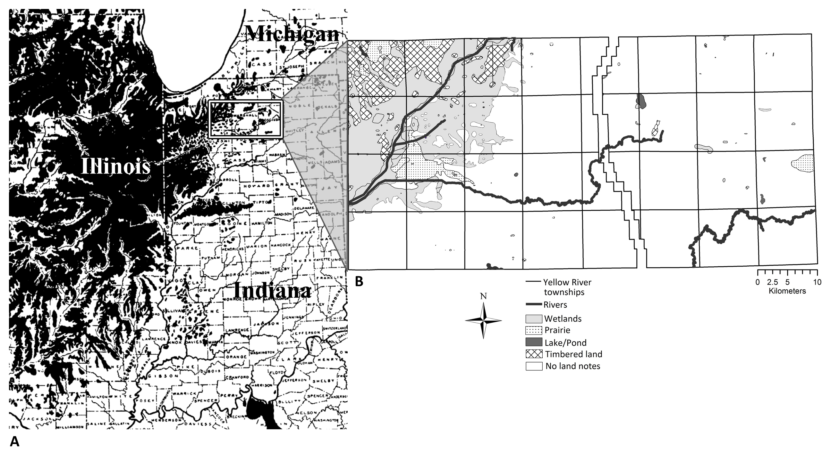

Figure 1.— Study Area. (A) Transeau’s (1935) depiction of the prairie before Euro-American settlement, with study area outlined (B) Yellow River watershed study area and a digitized surveyor-drawn map of the region. The area is composed of 32 townships (thick black outline) each broken into 36 1-mile sections. Surveyors described wetlands (marsh, swamp- in gray), timbered land (crosshatch), and prairie (stipple), but for most areas the plat maps do not give land cover data (white). The north-south break between the townships represents the Michigan Road Lands, not included in this study.

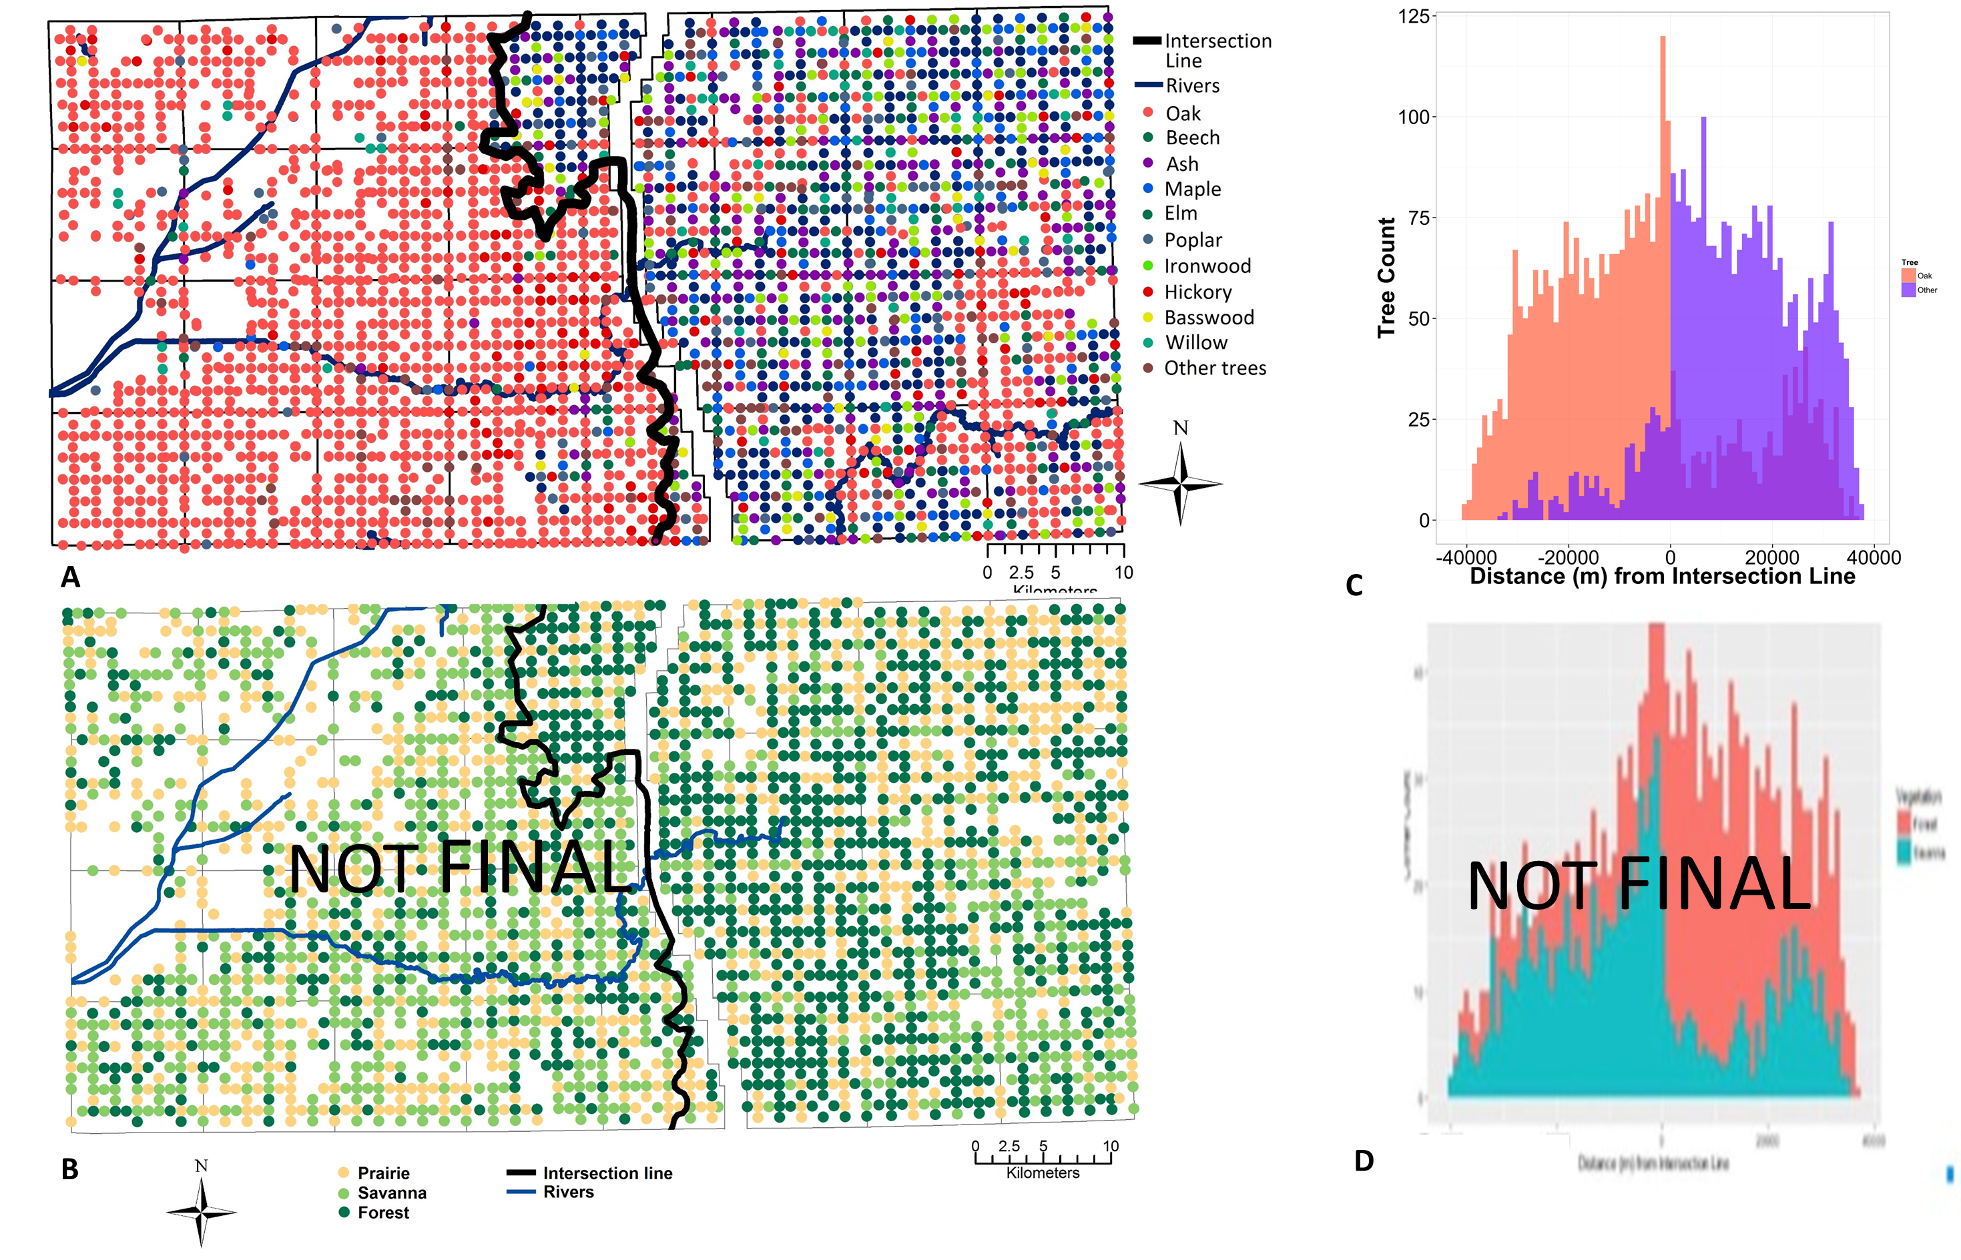

Figure 2.— Map of historic vegetation composition and structure. Yellow River watershed pre-settlement (A) tree composition with (B) corresponding histogram of oak/non-oak taxa on each side of the black midline. (C) Tree density at each corner (trees/ha) with (D) corresponding histogram. Histograms of (B) trees by taxonomic group (oak or non-oak) and (D) corners by tree density (as savanna or forest, based on the divisions in Goring et al. 2016) are shown at the minimum euclidian distance (m) from the black midline that bisected the study area.

Table 1.— Historic and modern vegetation. Pre-settlement (PLS data) and modern (FIA) average tree density, tree size, and species representation (by percent of trees) within each buffer. Taxa with over 2% composition were included. Density and tree size differed historically between the two areas, but not on the modern landscape.

|  |  |  |  |  |
| --- | --- | --- | --- | --- |
|  | **Historic** |  | **Modern** |  |
|  | **West** | **East** | **West** | **East** |
| **Average Stem Density** | 45.1_will update | 125.1_will update | 37.2 ± 4.9 | 43.9 ± 8.8 |
| **Average Diameter** | 40.3 ± 0.3 | 39.8 ±0.4 | 33.3 ± 1.2 | 35.5 ± 1.7 |
| **Taxa** |  | | | |
| Ash | 0.6 | 12.4 | 1.0 | 10.8 |
| Basswood | 0.4 | 2.4 |  |  |
| Beech | 0.3 | 20.7 | - | - |
| Black gum/sweet gum | 0.2 | 0.5 | 6.7 | - |
| Cherry | 0.1 | 0.3 | 21.0 | 9.2 |
| Elm | 1.1 | 9.1 | 2.9 | - |
| Hickory | 3.7 | 3.3 | 3.8 | - |
| Ironwood | 0.1 | 4.3 | - | - |
| Maple | 0.5 | 9.7 | 15.2 | 30.8 |
| Oak | 76.6 | 22.9 | 26.7 | 19.4 |
| White | 41.9 | 14.3 | - | - |
| Black | 17.9 | 0.8 | - | - |
| Yellow | 7.4 | 0.7 | - | - |
| Red | 5.3 | 2.7 | - | - |
| Bur | 2.4 | 3.5 | - | - |
| Other hardwood* | 0.3 | 0.1 |  |  |
| Pine | 0.0 |  | 3.8 | - |
| Poplar§ | *1.5* | *5.6* | - | 21.5 |
| Willow | 0.7 | 2.1 |  |  |

* Other hardwoods include: Alder, Buckeye, Birch, Hackberry, Black/Honey Locust*,* Mulberry, Sycamore, Walnut (*Juglans spp.*)

§ Due to the ambiguity in the common tree names used in the PLS records, Poplar could be tulip poplar (Liriodendron tulipifera) or aspen (Populus spp.) (Paciorek et al. 2016).

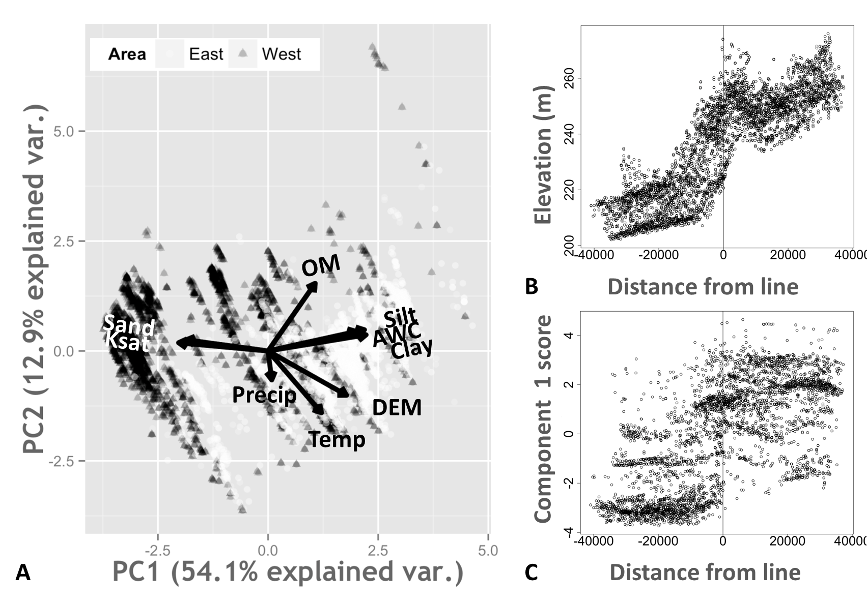

**B**

Figure 3.— Environmental gradient of watershed. (A) Principal component analysis biplot showing the variance explained by the first principal component (54.1%) and second component (12.9%). High sand content and ksat scores are associated with trees in the western oak area (black), whereas high elevation, silt and clay content and available water content is associated with trees in eastern mixed hardwood area (white). (B) Elevation and (C) PCA component 1 score are shown at the minimum euclidian distance (m) from the black midline that bisected the study area

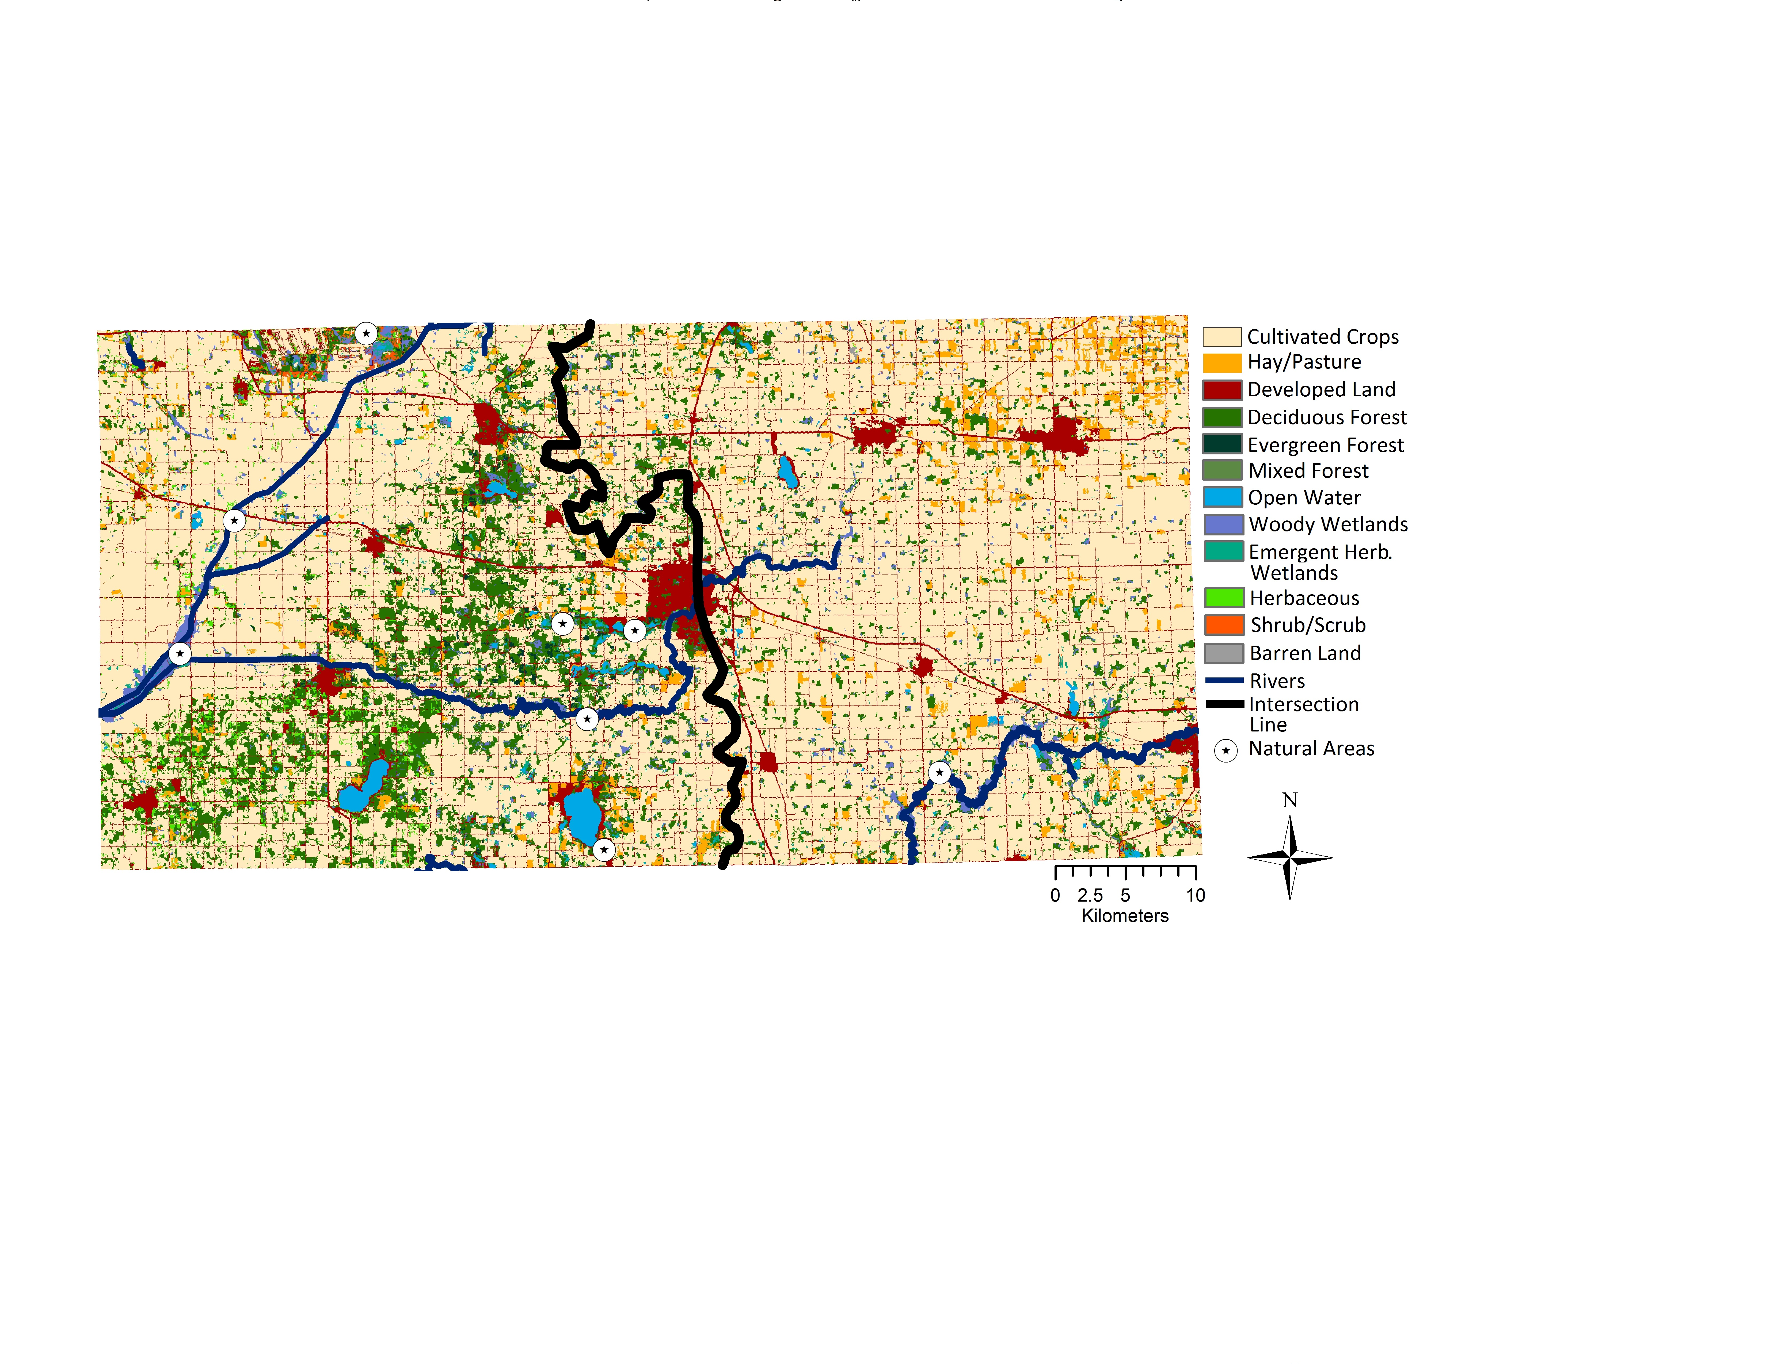

Figure 4.— Modern-day land use. 2006 land use of the Yellow River watershed in each historic vegetation area (overlaid with the black midline that separates the east mixed forests from the west oak savannas in the PLS maps). The eastern area had more trees in area that is now cultivated cropland (light yellow; 38.1% vs 33.6%), whereas the western vegetation area includes more modern forested land (green; 11.5% vs 4.9%). Nature preserves, parks and other green spaces within the study region are marked with black triangles.

Supplemental Material

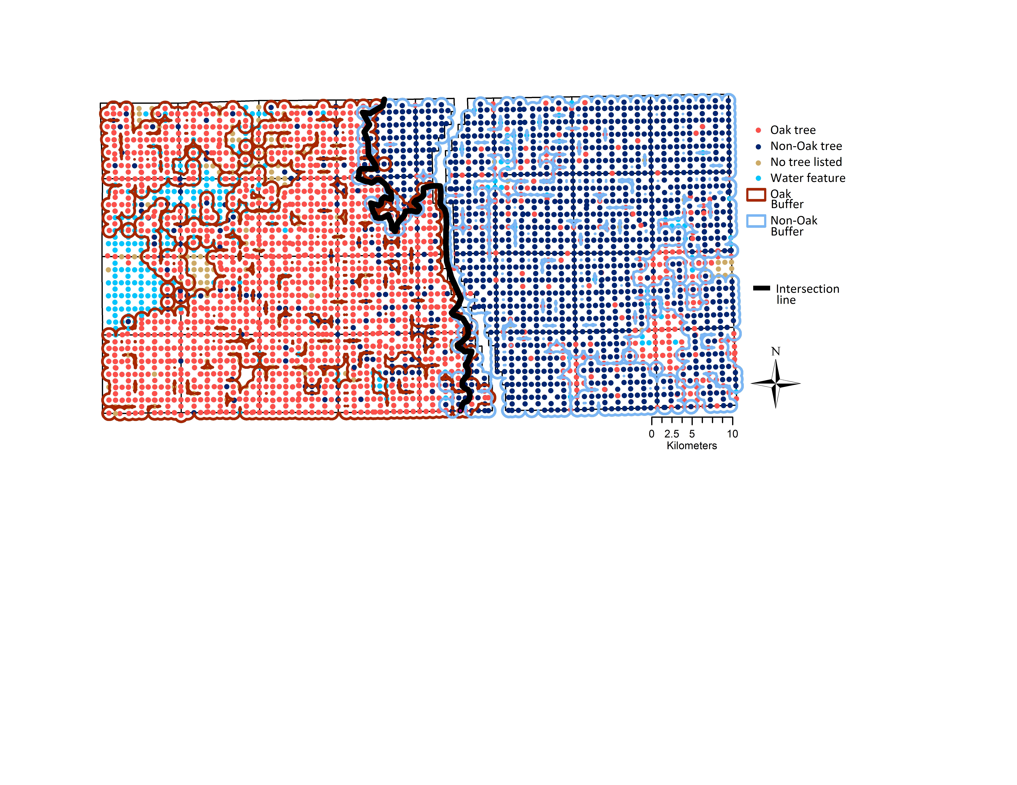

**Figure S1: Eastern and western buffers.** Buffers draw in ArcGIS with radius r=0.5 mi, around spatially continuous oak (orange) and non-oak (blue) species. In black, the midline between the two buffers dividing the study area into eastern (oak-dominated) and western (mixed forest) halves.

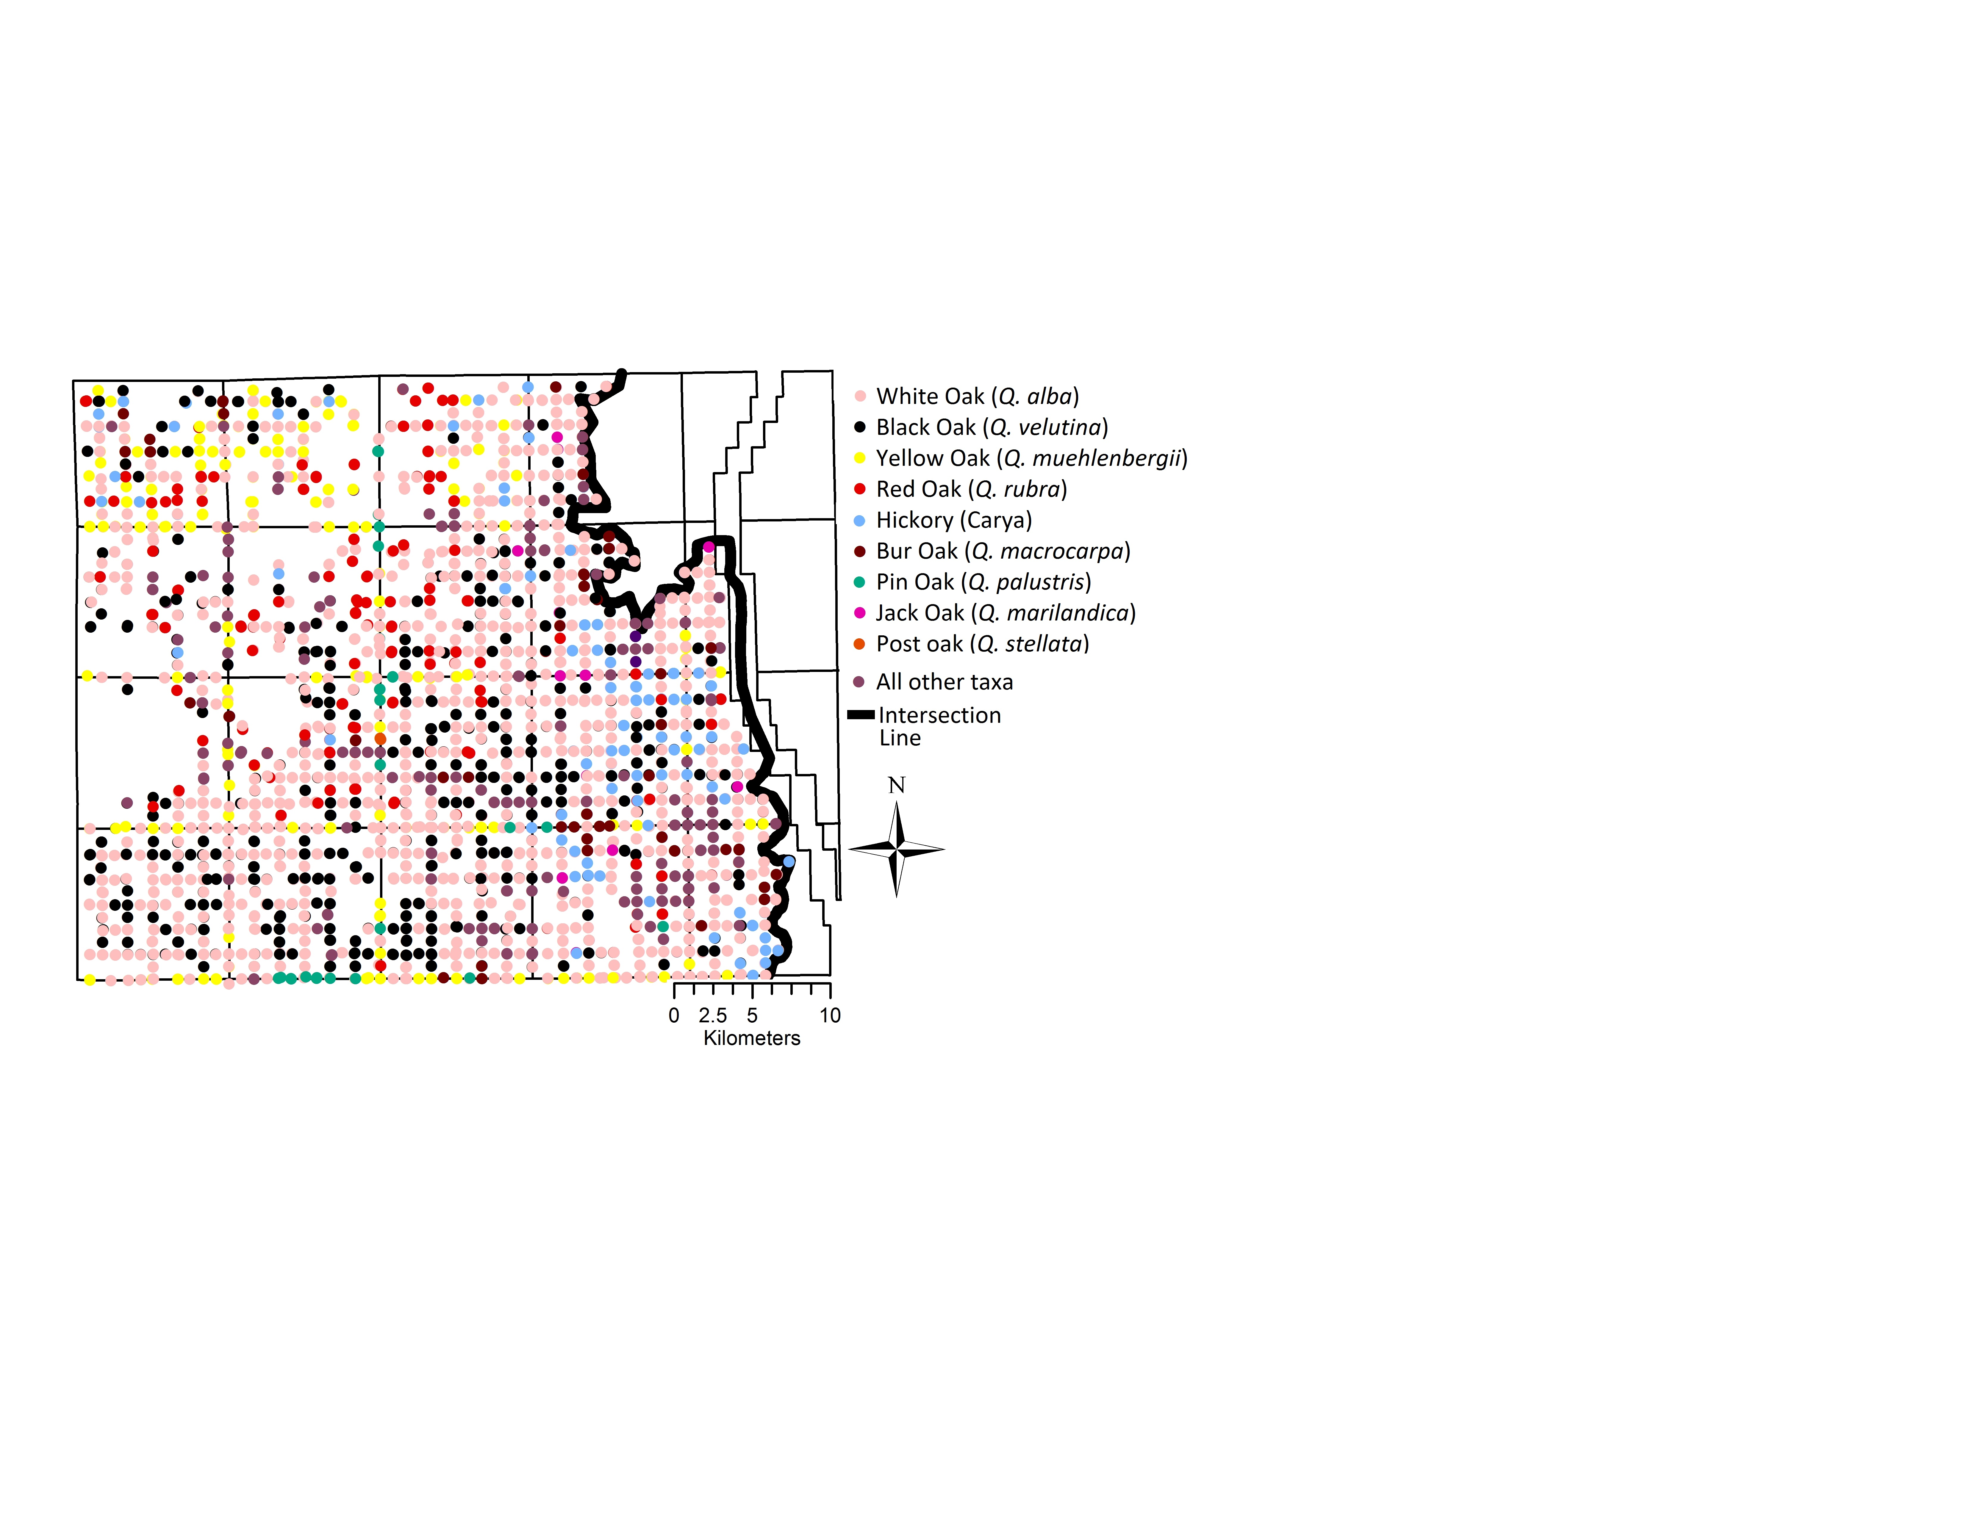

**Figure S2: Trees in western oak area further separated by species.** Especially fire-tolerant black oak (black) and burr oak (orange) are evenly distributed within the western region. This clarifies that tree species in the western side are not distributed in a way that suggests a gradient in tree ecological characteristics, and that it is appropriate to group the area as one association for comparative purposes.

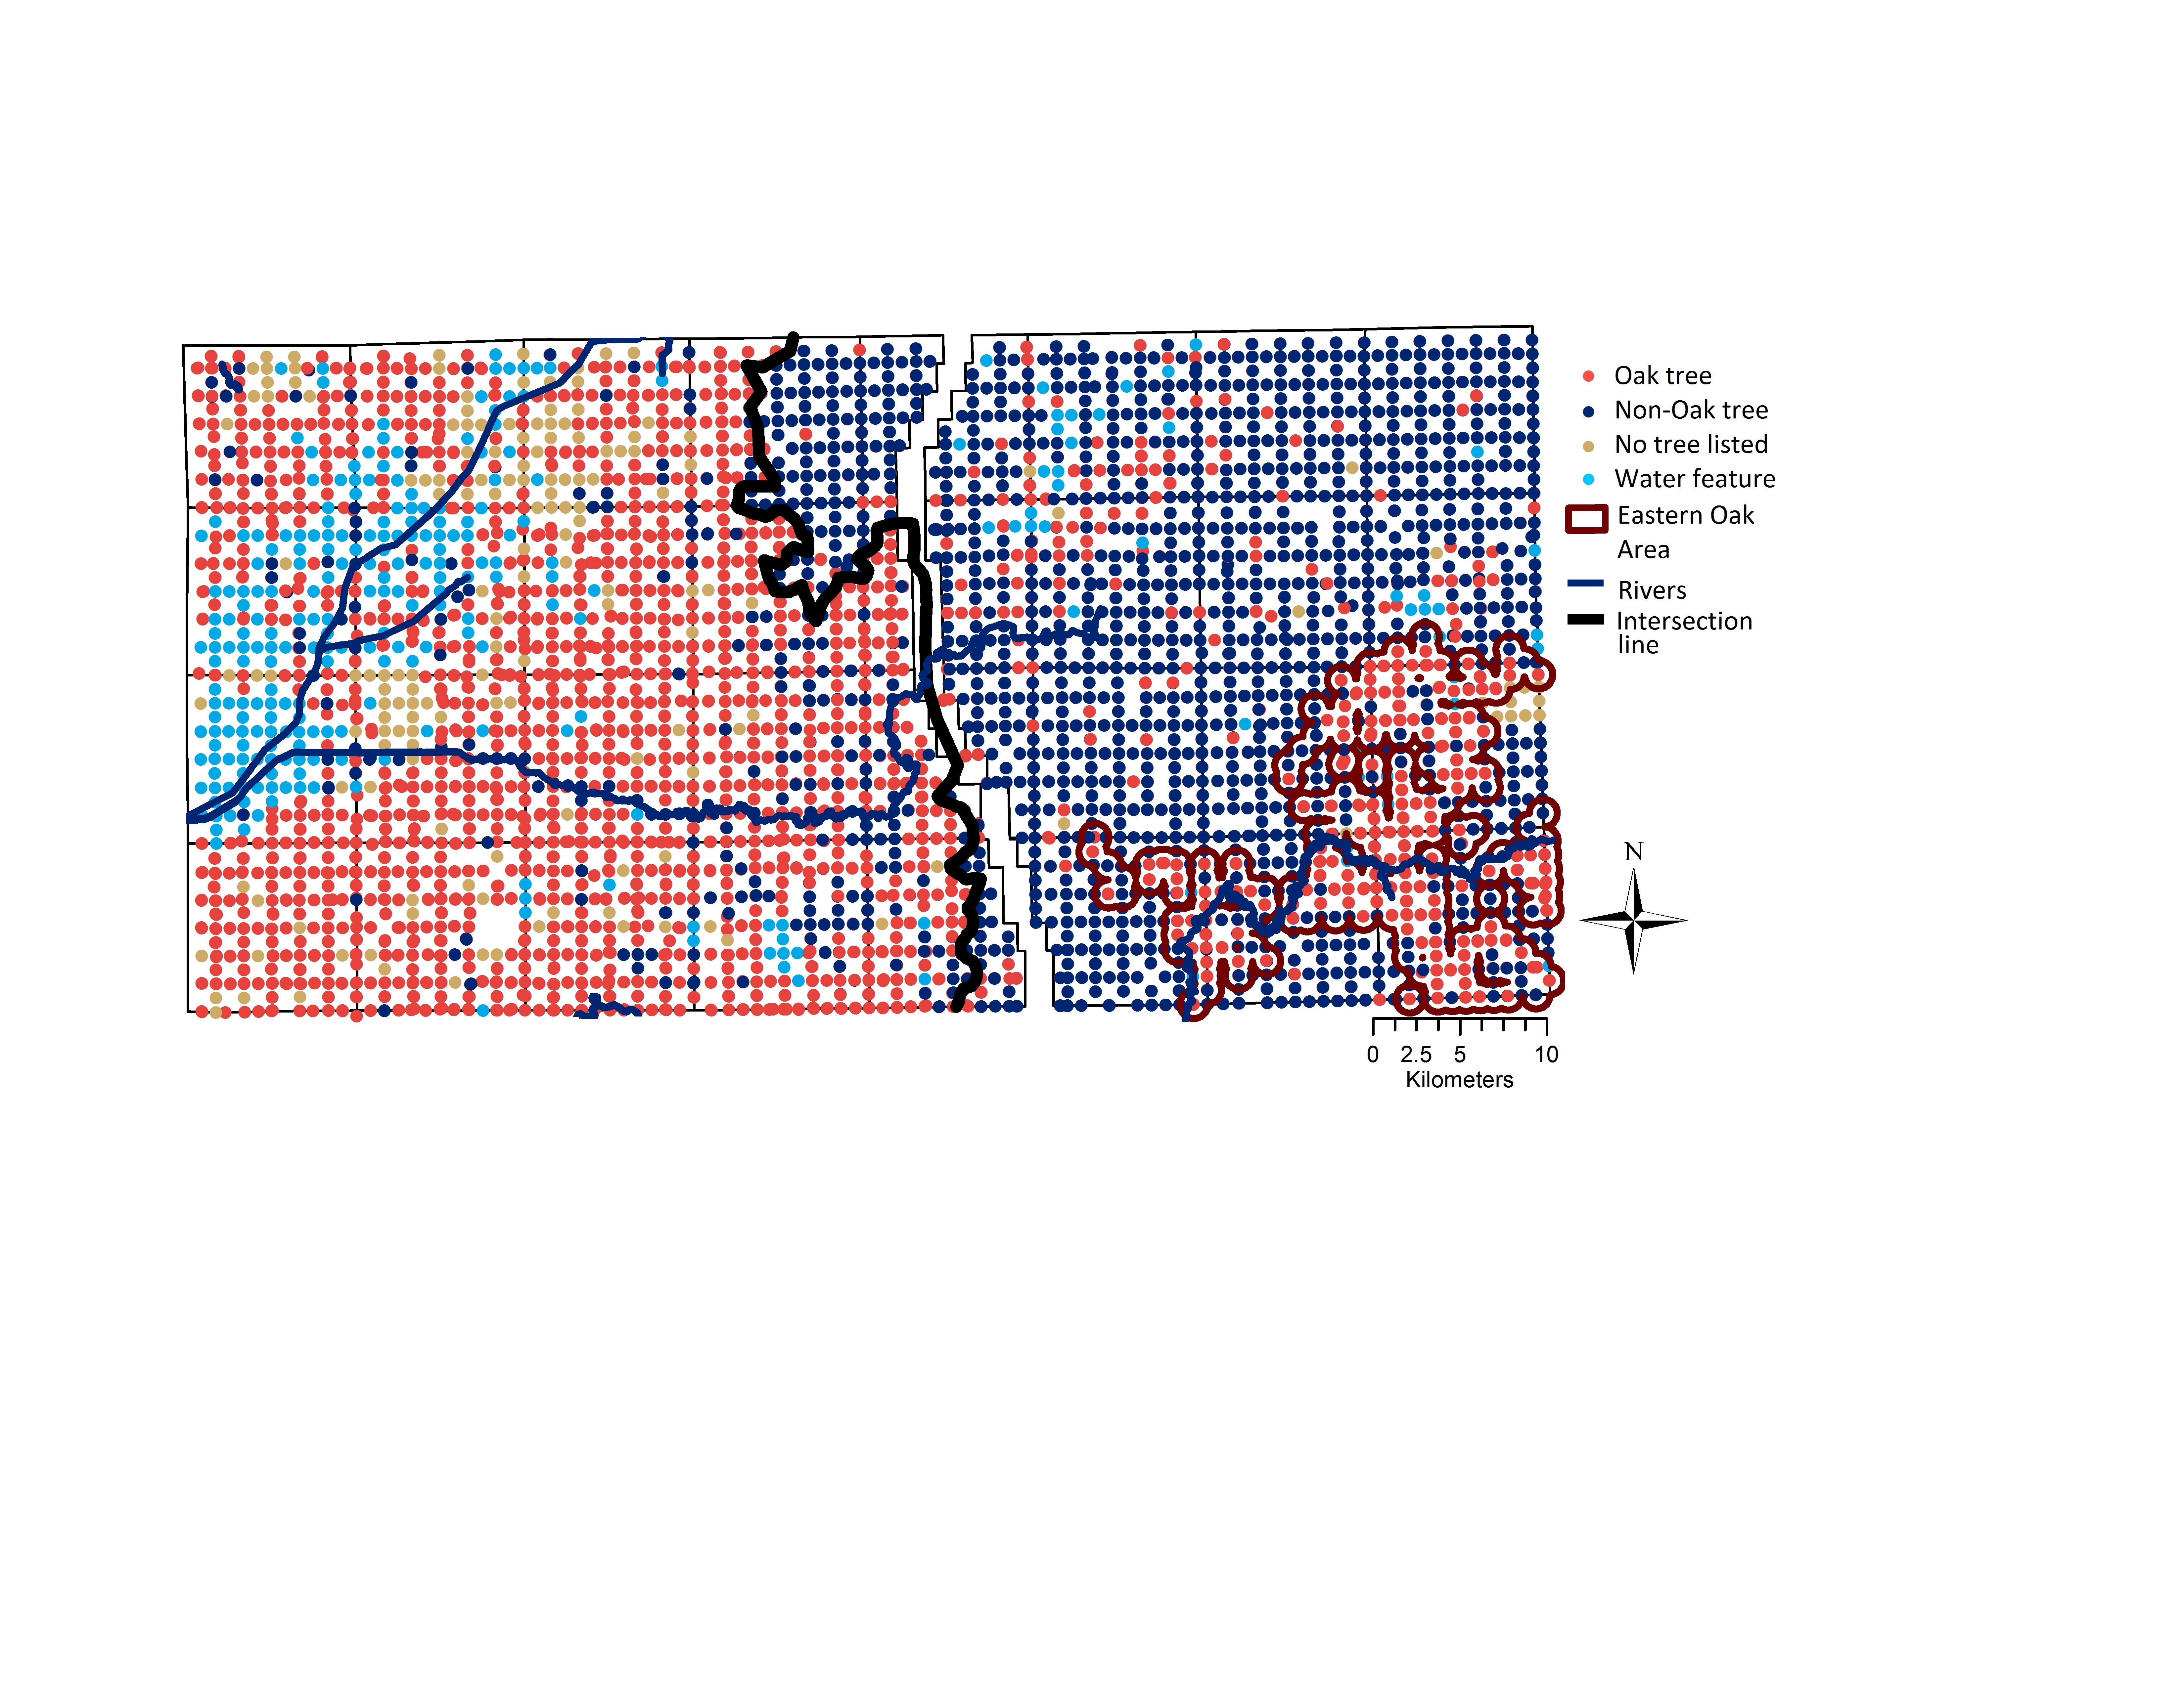

**Figure S3: Eastern oak area.** Cluster of oak dominance within the eastern region, quantified with the same ArcGIS buffer tool with radius r = 0.5 mi. This area includes 617 trees and 293 survey corners is used to compare forest structure and environmental characteristics

**A. 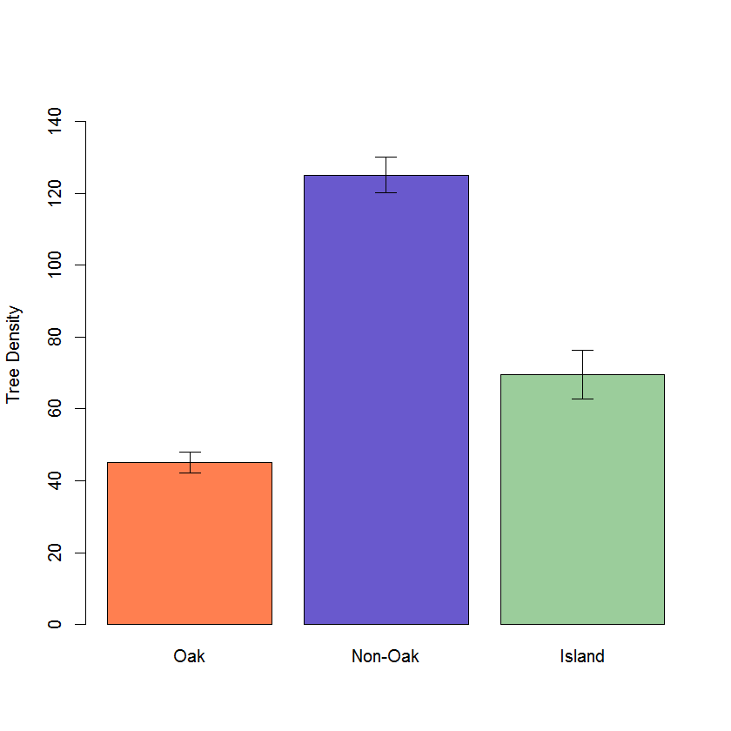 B.** 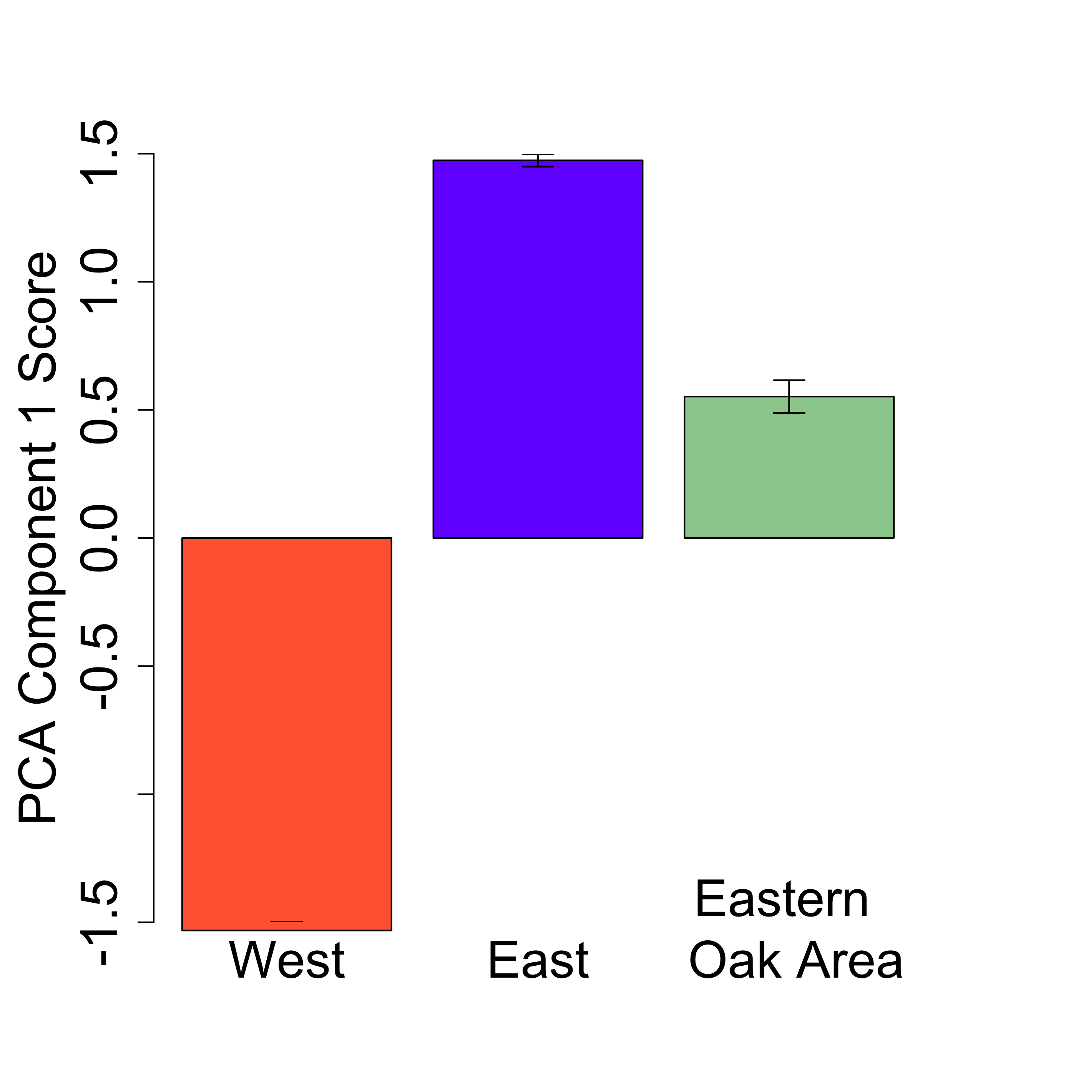

NOT FINAL

**Figure S4: Structure and environment of eastern oak area.** (A) Stem density and (B) first principal component score of the small eastern oak area, compared to the two main vegetation areas. Error bars represent standard error. Eastern aok region has intermediate density and environment, but more closely resembles the west in vegetation structure and the east in environment.

**Literature Cited**

Abrams, M. D. 1992. Fire and the development of oak forests. *BioScience*, **42**: 346-353.

Almendinger, J. C. 1992.The late Holocene history of prairie, brush-prairie, and jack pine (Pinusbanksiana) forest on outwash plains, north-central Minnesota, USA. *The Holocene*, **2**:37-50.

Anderson, R. C. 1998. Overview of Midwestern oak savanna. *Transactions of the Wisconsin Academy of Science, Arts, and Letters*, **86**:1-18.

Anderson, R. C. and M. R. Anderson. 1975. The Presettlement Vegetation of Williamson County, Illinois.  *Castanea*, **40**:345–363,

Batek, M. J., A. J. Rebertus, W. A. Schroeder, T. L. Haithcoat, E. Compas and R. P. Guyette. 1999. Reconstruction of early nineteenth‐century vegetation and fire regimes in the Missouri Ozarks. *J. Biogeogr.,***26**:397-412.

Bowles, M. and M. Jones. 2004. The Prairie-Wetland Vegetation Continuum in the Chicago Region of Northeastern Illinois. *Proceedings of the North American Prairie Conferences*, Paper 64.

Bowles, M. and J. McBride. 2001. Historic landscape vegetation pattern, composition, and structure of Will County, Illinois, as recorded by the U. S. Public Land Survey (1821-1838). The Morton Arboretum.

Brewer, L. G. and J. L. Vankat, 2004. Description of Vegetation of the Oak Openings of Northwestern Ohio at the Time of Euro-American Settlement. *Ohio J. Sci.*, **104**: 76.

Brugam, R. B., P. Kilburn, P. and L. Luecking. 2016. Pre-settlement Vegetation of Greene, Jersey and Macoupin Counties along the Prairie/Forest Border in Illinois. *Illinois State Academy of Science. Transactions*, **109**:9.

Chicago Sanitary District (Ill.). Board of Trustees. 1895. Proceedings of the Board of Trustees of the Sanitary District of Chicago. Chicago, Ill.: The Board. 2998.

Christopher B. Burke Engineering, LLC. 2012. Yellow River Sediment Control Evaluation Preliminary Engineering Report.

Cowles, H. C. 1901. The Physiographic Ecology of Chicago and Vicinity; A Study of the Origin, Development, and Classification of Plant Societies. *Bot. Gaz*., **31**:145-182.

Curtis, J. T. and R. P. McIntosh. 1951. An upland forest continuum in the prairie‐forest border region of Wisconsin. *Ecology*, **32**:476-496.

Danz, N. P., P. B. Reich, L. E. Frelich and G. J. Niemi. 2011. Vegetation controls vary across space and spatial scale in a historic grassland‐forest biome boundary. *Ecography*, **34**:402-414.

Deines, J. M., D. Williams, Q. Hamlin and J. S. McLachlan. 2016. Changes in forest composition in Ohio between Euro-American settlement and the present. *The American Midland Naturalist*, **176**:247-271.

Downey, M. H., W. D. Pence and C. G. Elliott. 1909. Report upon the drainage of agricultural lands in the Kankakee River Valley, Indiana. *Circular (United States. Office of Experiment Stations),* 80.

Elton, W. M. 1970. Forest Distribution and Soil Texture Along the Valparaiso Moraine in Northwestern Indiana. *The Geographical Bulletin*, **1**:41.

Fahey, R. T., M. L. Bowles and J. L. McBride. 2012. Origins of the Chicago urban forest: composition and structure in relation to presettlement vegetation and modern land use. *Arboriculture & Urban Forestry*, **38**:181-193.

Fahey, R.T., L. Darling and J. Anderson. 2015. Oak Systems Recovery Plan. Chicago Wilderness.

Friedman, S. K. and P. B. Reich. 2005. Regional legacies of logging: departure from presettlement forest conditions in northern Minnesota. *Ecol. Appl.*, **15**:726-744.

Fry, J., G. Xian, S. Jin, J. Dewitz, C. Homer, L. Yang, C. Barnes, N. Herold and J. Wickham. 2011. Completion of the 2006 National Land Cover Database for the Conterminous United States. *PE&RS*, **77**:858-864.

Fuller, G. D. 1925.*The Vegetation of the Chicago Region: An Outline of Some of the Principal Plant Associations Together with Lists of Their Principal Species*. The University of Chicago Press.

Goring, S. J.,D. J. Mladenoff, C. V. Cogbill, S. Record, C. J. Paciorek, S. T. Jackson, M. C. Dietze, A. Dawson, J. H. Matthes, J. S. McLachlan and J. W.  Williams. 2016. Novel and Lost Forests in the Upper Midwestern United States, from New Estimates of Settlement-Era Composition, Stem Density, and Biomass. *PloS One*, **11**:1-34.

Grimm, E. C. 1984.Fire and Other Factors Controlling the Big Woods Vegetation of Minnesota in the Mid‐Nineteenth Century. *Ecol. Monogr.*, **54**:291-311.

Jonas, M. and C. Little. 2010. SIAM Case Study: Kankakee River Basin, Indiana and Illinois. 2nd Joint Federal Interagency Conference. Las Vegas, NV.

Hanberry, B. B., B. J. Palik and H. S. He. 2012. Comparison of historical and current forest surveys for detection of homogenization and mesophication of Minnesota forests. *Landscape Ecology,* **27**: 1495-1512.

Haney, A., M. Bowles, S. Apfelbaum, E. Lain, E. and T. Post. 2008. Gradient analysis of an eastern sand savanna's woody vegetation, and its long-term responses to restored fire processes. *Forest Ecology and Management*, **256**:1560-1571.

Higgins, S. I., W.J. Bond and W. S. Trollope. 2000. Fire, resprouting and variability: a recipe for grass–tree coexistence in savanna. *Journal of Ecology*, **88**: 213-229.

Ivens, J. L., N. G. Bhowmilk, A. R. Brigham and D. L. Gross. 1981. The Kankakee River Yesterday and Today. Illinois Department of Energy and Natural Resources.

Kenoyer, L. A. 1933. Forest distribution in southwestern Michigan as interpreted from the original land survey (1826–32). *Papers of the Michigan Academy of Science, Arts, and Letters,***19**:107–111.

Kilburn, P. D. 1959.The forest-prairie ecotone in northeastern Illinois. *American Midland Naturalist*, 206-217.

Leach, M. K. and T. J. Givnish. 1999. Gradients in the composition, structure, and diversity of remnant oak savannas in southern Wisconsin. *Ecol. Monogr.*, **69**:353-374.

Lindsey, A. A., W. B. Crankshaw and S. A. Qadir. 1965. Soil relations and distribution map of the vegetation of presettlement Indiana. *Bot. Gaz.*, **126**:155-163.

Liu, F., D. J. Mladenoff, N. S. Keuler and L. S. Moore. 2011. Broadscale variability in tree data of the historical Public Land Survey and its consequences for ecological studies. *Ecol. Monogr.*, **81**:259-275.

Manies, K. L. and D. J. Mladenoff, D. J. 2000. Testing methods to produce landscape-scale presettlement vegetation maps from the US public land survey records. *Landsc. Ecol.*, **15**: 741-754.

Manogaran, C. 1983. The prairie peninsula: a climatic perspective. *Physical Geography*, **4**:153-166.

The Nature Conservancy. 2017. Ober Sand Savanna. <http://www.nature.org/ourinitiatives/regions/northamerica/unitedstates/indiana/placesweprotect/ober-sand-savanna-1.xml>

Nowacki, G. J. and M. D. Abrams. 2008. The demise of fire and “mesophication” of forests in the eastern United States. *BioScience*, **58**:123-138.

Paciorek, C. J., S. J. Goring, A. L. Thurman, C. V. Cogbill, J. W. Williams, D. J. Mladenoff, J. A. Peters, J. Zhu and J. S. McLachlan. 2016. Statistically-estimated tree composition for the northeastern United States at Euro-American settlement. *PloS One.* **11**:1-20.

Paulson, A. K., S. Sanders, J. Kirschbaum and D. M. Waller. 2016. Post‐settlement ecological changes in the forests of the Great Lakes National Parks. *Ecosphere*, **7**:1-20.

Phillippe, L. R., M. A. Feist, D. T. Busemeyer, P. B.  Marcum, C. J. Carroll, G. R. Spyreas and J. E. Ebinger. 2011. Vegetation of Forest and Savanna Communities on Glacial Sand Deposits in Northeastern Illinois. *The Southwestern Naturalist*, **56**:54-60.

Prather, P. 1943. The Struggle for the Michigan Road. *Indiana Magazine of History,* **39**:1-24.

Ratajczak, Z., J. B. Nippert and T. W. Ocheltree. 2014. Abrupt transition of mesic grassland to shrubland: evidence for thresholds, alternative attractors, and regime shifts. *Ecology*, **95**:2633-2645.

Reich, P. B., D. W. Peterson, D. A. Wedin and K. Wrage. 2001. Fire and vegetation effects on productivity and nitrogen cycling across a forest–grassland continuum. *Ecology*, **82**:1703-1719.

Rodgers, C. S. and R. C. Anderson. 1979. Presettlement vegetation of two prairie peninsula counties. *Bot. Gaz*., **140**:232-240.

Staver, A. C., S. Archibald and S. Levin. 2011. Tree cover in sub‐Saharan Africa: Rainfall and fire constrain forest and savanna as alternative stable states. *Ecology*, **92**:1063-1072.

Thomas, R. and R. C. Anderson. 1990. Presettlement vegetation of the Mackinaw river valley, central Illinois. *Transactions of the Illinois State Academy of Science*, **80:**10-22

Thompson, M. 1886. Fifteenth Annual Report. Indiana Department of Geology and Natural History.

Transeau, E. N. 1935.The prairie peninsula.*Ecology,***16**:423-437.

Weaver, J.E., 1960. Flood plain vegetation of the central Missouri Valley and contacts of woodland with prairie. *Ecol. Monogr.*, **30**:37-64.

Whelan, R J. 1995.*The Ecology of Fire*. Cambridge university press.

Whitney, G. G. and J. R. Steiger, J. R. 1985. Site-factor determinants of the presettlement prairie-forest border areas of north-central Ohio. *Bot. Gaz.*, **146**:421-430.

Woods, A. J., J. M. Omernik, C. L. Pederson and B. C. Moran. 2006. Level III and IV ecoregions of Illinois. EPA/600/R-06/104. USEPA National Health and Environmental Effects Research Lab., Corvallis, OR.

UmbanhowarJr, C. E. 2004. Interaction of fire, climate and vegetation change at a large landscape scale in the Big Woods of Minnesota, USA.*The Holocene*, **14***:*661-676.

U.S. Census Bureau. 2015. County Population Totals Datasets: 2010-2015*..* Retrieved from [URL].

van Langevelde, F., C. A. van de Vijver, L. Kumar, J. van de Koppel, N. de Ridder, J. van Andel, A. K. Skidmore, J. W. Hearne, L. Stroosnijder, W. J. Bond and H. H. Prins. 2003. Effects of fire and herbivory on the stability of savanna ecosystems. *Ecology*, **84**:337-350.